From Logo to Icon
Turning a project emblem into a working software icon
Sangala Studio carries the image of an African buffalo, Samweli Wanda, designed and built in LEGO bricks by Moses Kumenya, the Sangala Innovation Teacher at Hawthorne-Scribner High School. This document records how that emblem became the program’s icon, and is written so the same steps can be followed for any other program that needs one.
The starting material was a photograph of a physical object. The process is the same whether the emblem begins as a photograph, a drawing, or a paper cut-out.

1. Design for the smallest size, not the largest
Windows does not ask for one icon. It asks for the same icon at several sizes and picks whichever fits the place it is drawing: roughly 256 pixels in file dialogs, 48 on the desktop, 32 in the taskbar, and 16 in the title bar and the system tray.
The 16-pixel version governs every decision. An icon that is handsome at 256 pixels and unreadable at 16 is a failed icon, because 16 is where users spend most of their time looking at it. Judge every choice at the smallest size before admiring it at the largest.

2. Crop to the one identifying feature
The first attempt used the whole model, and it did not survive. At 16 pixels the legs, the baseplate, and the body collapse into an undifferentiated brown smear.
Cropping to the head keeps the two shapes that identify the animal: the pale sweep of the horn and the dark mass of the face. Those two survive the reduction; nothing else does.
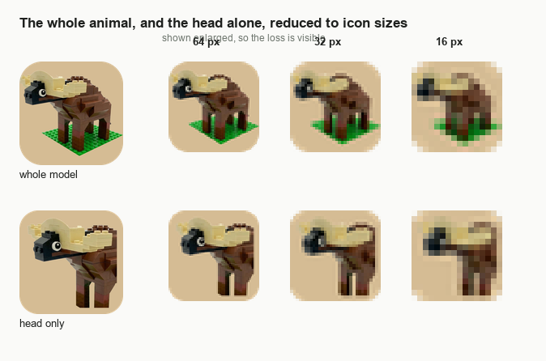
Figure 1. The whole model and the head alone, each reduced to 64, 32, and
16 pixels. Only the head survives the reduction.
The general rule is worth stating plainly, because it applies to any emblem. An icon is not a small picture of the thing. It is the one feature of the thing that is still legible at 16 pixels. Decide what that feature is before doing any other work, then crop hard to it.

3. Give the icon a tile
Artwork with a transparent background looks clean in isolation and disappears in use. A dark subject vanishes against a dark taskbar; a pale one vanishes against a light one. The user cannot control which they have.
A solid rounded tile behind the subject solves this. It guarantees contrast on any background, and it gives the program a constant silhouette, so the icon becomes findable by shape before it is recognized by content.
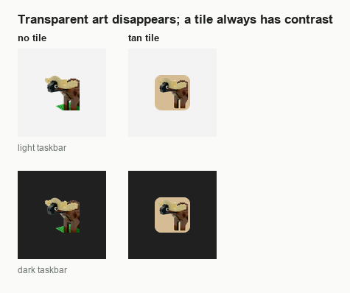
Figure 2. The same artwork with and without a tile, over a light and a dark taskbar.
Take the tile color from the subject rather than choosing one freshly. Sangala’s tile is the tan of the buffalo’s own horn, which keeps the icon looking like one object rather than a picture pasted onto a square.

4. Build one .ico containing every size
An .ico file is a container. A single file holds the artwork at several resolutions, and Windows selects among them.
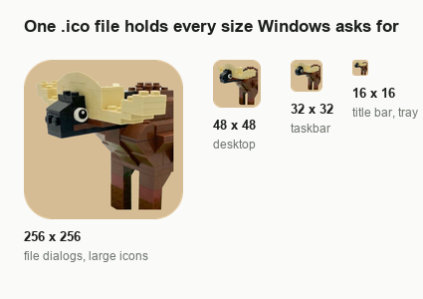
Figure 3. The sizes inside Sangala.ico, and where Windows uses each of them.
Sangala.ico holds six: 256, 128, 64, 48, 32, and 16 pixels. Build all of them. The tempting shortcut is to ship a single 256-pixel image and let Windows reduce it on demand, but automatic reduction produces a soft, muddy 16-pixel icon, which is precisely the size that matters most. Where a size looks poor after reduction, redraw it rather than accepting it.

5. Compile the icon into the executable
The icon is embedded at build time by the compiler, not shipped alongside the program. In Build SangalaStudio.cmd the flag is a single line on the csc command:
/win32icon:"Sangala.ico" ^
Guard the build so a missing icon fails loudly rather than silently producing an unbranded executable:
if not exist "Sangala.ico" ( echo Could not find Sangala.ico ^(the program icon^) in this folder. & pause & exit /b 1 )

6. Let every other surface inherit from the executable
A program shows its icon in more than one place, and the temptation is to set each one separately. Do not. Point every surface at the executable, so the icon can never drift out of step with itself.
- Tray icon. The tray reads the icon out of the running program rather than from a file: Icon.ExtractAssociatedIcon(Application.ExecutablePath), with SystemIcons.Application as a fallback if that fails. Nothing extra ships, and the tray can never disagree with the title bar.
- Desktop shortcut. The shortcut is created in PowerShell through WScript.Shell, setting TargetPath to the executable. It deliberately does not set IconLocation. A shortcut with no icon of its own inherits the target’s, so rebuilding the program updates the shortcut too.
- Distribution. Update SangalaStudio.cmd recreates the shortcut on both of its paths, the already-current path and the after-updating path, so testers receive the icon without being told to do anything.

7. Three things that went wrong
These cost time on the first pass and are worth checking deliberately.
- An artifact invisible at full size. The source image carried a small colored wedge left over from editing. At full resolution it read as background noise. Once cropped and tiled it sat in plain view. Inspect the source at the crop you intend to use, not at the size you happen to have it open.
- The stale shortcut. After rebuilding with a new icon, the desktop shortcut kept showing the old one. Windows caches shortcut icons, and the cache does not notice that the target changed. Deleting and recreating the shortcut is the reliable fix, which is why the updater recreates it every time rather than only when it is missing.
- Judging at the wrong size. Every early version was assessed at 256 pixels, where all of them looked acceptable. The differences that mattered only appeared at 16.

8. Checklist for the next program
- Choose the feature. Name the one shape that must survive at 16 pixels before doing anything else.
- Crop hard to it. Discard everything that will not read, however good it looks large.
- Clean the source. Inspect it at the intended crop for artifacts.
- Add a tile. Take its color from the subject; check it against a light and a dark background.
- Export every size. 256, 128, 64, 48, 32, 16 in one .ico; look at each at actual size.
- Embed at build time. /win32icon: on the compiler line, with a guard if the file is absent.
- Inherit everywhere else. Tray from the executable, shortcut with no IconLocation of its own.
- Recreate the shortcut on update, so the icon reaches users who never rebuild anything.

